LEANFT LINUX INSTALLATION:

1. Log into HPE SaaS <https://saas.hpe.com/en-us/download/leanft> . If you do not have an account, create one.
2. Go to the LeanFT download page, and download the installation file for Linux.
3. In Terminal, extract the installation file: tar -xzvf LeanFTSetup_Linux.tar.gz
4. Launch the installation:

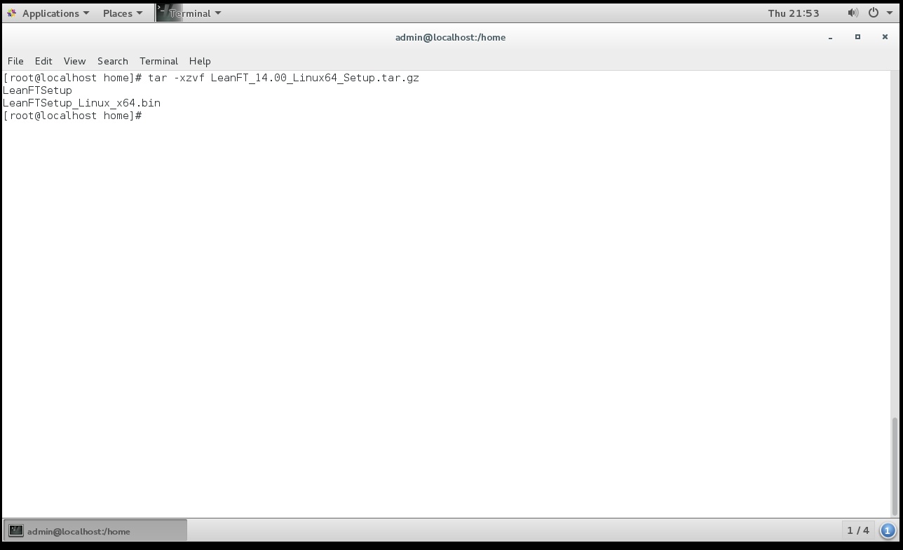

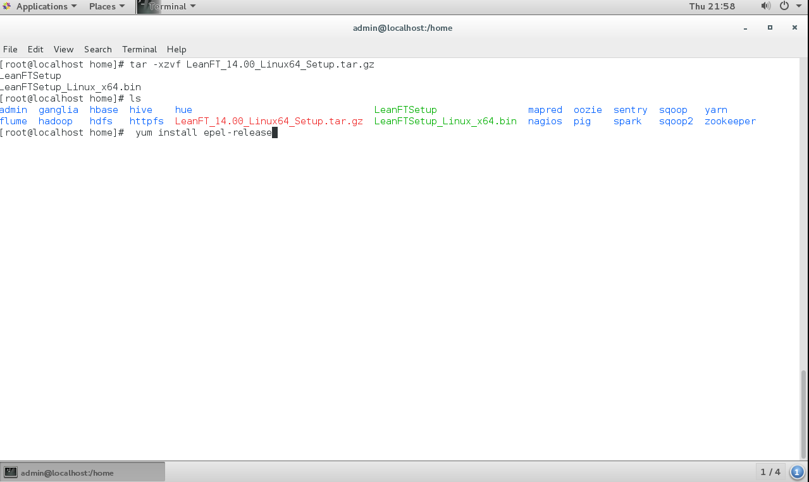

5. Node.js must be installed (If Node.js is not installed, the installation will fail.)

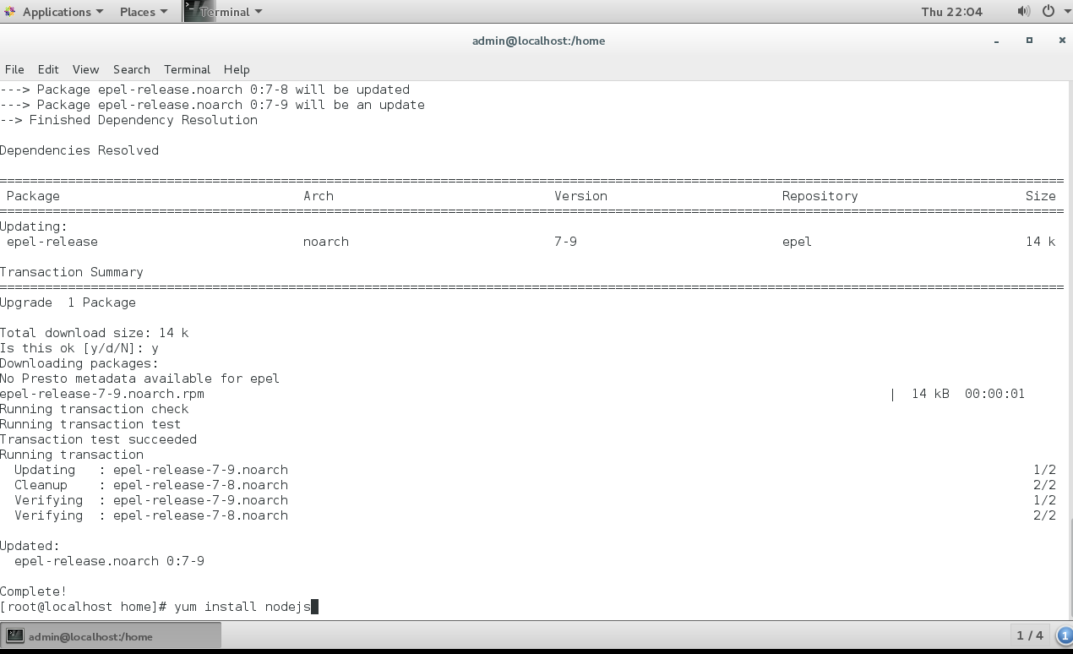

C:\Users\vidhya\Downloads\5.PNG

C:\Users\vidhya\Downloads\6.PNG

1. Install LeanFT (./LeanFTSetup_Linux_x64.bin)

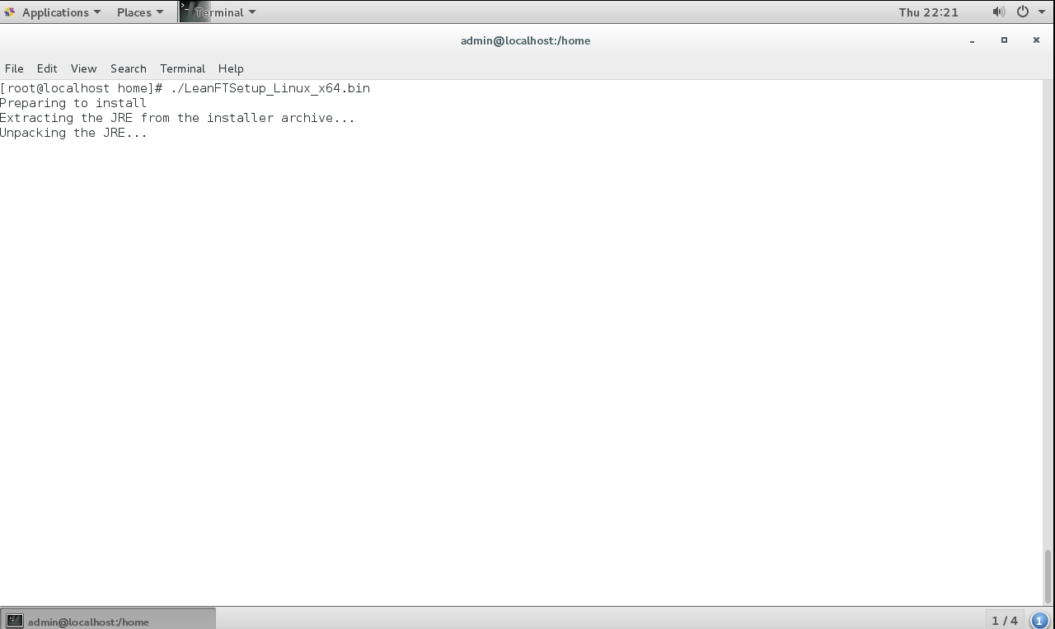

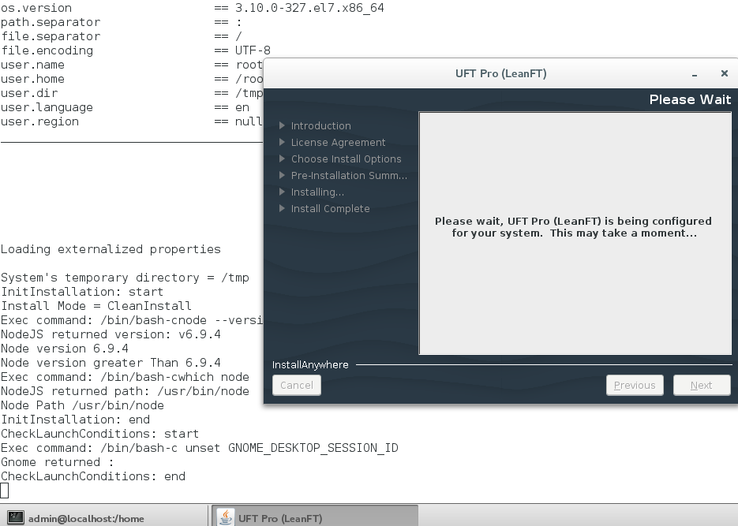

1. When selecting the IDE (Eclipse and/or IntelliJ IDE) on which to install the LeanFT plugin, enter the full folder path.
2. When the full installation is complete, a LeanFT menu is added to the IDEs you selected, and LeanFT project templates are available in the IDE.

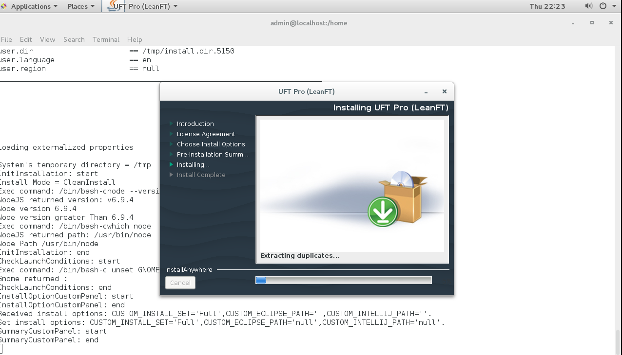

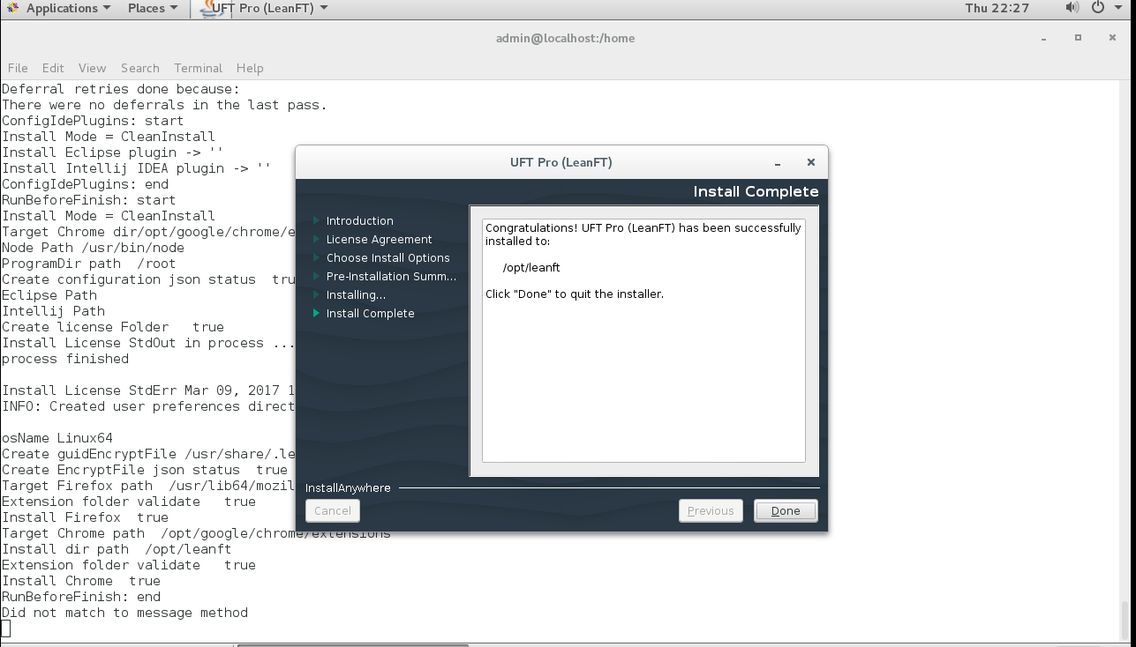

Note: If you choose not to install the LeanFT plugin on any IDEs, the LeanFT SDKs are still installed in /opt/leanft/sdk

